Title: | Window Lifter  SW Component

History
Issue status  (Index) | Maturity/Date  (draft/invalid/valid)  (dd-mmm-yyyy) | Author  Department | Check/Release  Department | Description
1.0 | Draft  19-0ct-2017 | Luis Archundia | Luis Archundia | Document inception
2.0 | Draft  27-0ct-2017 | Luis Archundia | Luis Archundia | Document Editing (Functional Description)
3.0 | Draft  27-0ct-2017 | Luis Archundia | Luis Archundia | Document Editing (Physical Block Diagram)
4.0 | Draft  28-0ct-2017 | Jorge Olvera | Jorge Olvera | Document Editing (Uses Case Diagram)
5.0 | Draft  29-0ct-2017 | Jorge Olvera | Jorge Olvera | Document Editing (Software Component Internal Breakdown)
6.0 | Draft  29-0ct-2017 | Jorge Olvera | Jorge Olvera | Document Editing ( Functional Decomposition)
7.0 | Draft  29-0ct-2017 | Luis Archundia | Luis Archundia | Document Editing (Purpose, Realization, Constraints and Targets)
8.0 | Draft  29-0ct-2017 | Jorge Olvera | Jorge Olvera | Document Editing (Function description and dynamic behavior)
9.0 | Draft  05-Nov-2017 | Jorge Olvera | Jorge Olvera | Document Editing (Physical Block Diagram)

Table of Contents
1 Purpose 3
2 Definitions and abbreviations 3
3 Realization constraints and targets 3
4 SW Conceptual design 5
4.1 Block Diagram for conceptual design description 5
4.2 Uses Case Diagram for requirements analysis 6
5 SW Component internal breakdown 9
5.1 Activity diagrams to identify software components 9
5.2 Physical Block Diagram for Design Description 11
5.3 Functional Decomposition 13
5.4 Function Description and Dynamic Behavior 14
5.4.1 void wc_void_ControlWindowUp (T_UBYTE * porcent) 14
5.4.2 void wc_void_ControlWindowDown (T_UBYTE * porcent) 15
5.4.3 T_UBYTE bc_ T_UBYTE _statusButt_Up () 16
5.4.4 T_UBYTE bc_ T_UBYTE _statusButt_Down () 16
5.4.5 void ic_void_onIndicator_Up () 17
5.4.6 void ic_void_offIndicator_Up () 17
5.4.7 void ic_void_onIndicator_Down () 18
5.4.8 void ic_void_offIndicator_Down () 18
5.4.9 void tmr1ms_void_EnableTimer1ms () 19
5.4.10 void tmr1ms_void_DisableTimer1ms () 19

Purpose
To provide an embedded SW solution based on the ARM Cortex M4 Microcontroller along with a hardware functional prototype, capable of emulating the behavior of a car’s window lifter module, using an LED bar and NXP’s S32K144 Development Kit Platform, implementing basic movement functionalities as well as safety and comfort features. This embedded SW application shall emulate the control of the window’s movement in two (2) directions; up and down.

Definitions and abbreviations
Definitions
T_UBYTE | Data type unsigned char
T_UWORD | Data type unsigned int
T_ULONG | Data type unsigned long
S_GPIO_Type | General purpose input output (GPIO) Structure
S_PORT_Type | PORT Structure
S_PCC_Type | Peripheral clock control PCC Structure
S_LPIT_Type | Low power interrup (LPIT) Structure
S_WDOG_Type | Watchdog (WDOG) Structure

Abbreviations
SW | Software
SDK | Software Development Kit (platform)
ms | Miliseconds
MAL | Microcontroller abstraction layer
HAL | Hardware abstraction layer
APP | Application layer
src | Source
io | Input /output
init | initialization
bc | buttonscontrol file .c /.h
wc | windowcontrol file .c / .h
ic | Indicatorcontrol .c / .h
UML | Unified modeling language

References
N° | Document name
1 | WindowLifterRequirementsLetter
2 | WindowLifter_TraceabilityMatrix
3 | Test_Plan_WindowLifter

Realization constraints and targets

To create a SW solution along with a functional hardware prototype that is capable of emulating the behavior of a car’s window movement along with the use of simple hardware components such as a 10 LED bar.
The solution provided must be developed using the NXP S32K144EVB Development Kit Platform provided.
The solution must consider implementing basic functionality such as upward/downward movement, automatic movement using the provided mechanical interfaces within the platform, as well as safety functionality such as an “Anti-Pinch” functionality and fail proven activation algorithms such as a de-bouncing mechanism (software de-bounce).
The project must also consider timing critical. It is mandatory that it comply within the time boundaries previously agreed in the requirements document.

Two buttons shall indicate window’s movement button #1 for upward movement and button #2 for downward movement.
While the RED color of the LED bar will Indicate the window’s movement and height. LED bar should turn its LEDs on and off in order to indicate movement. Upward movement (LEDs ON) means window closing, while downward movement (LEDs OFF) indicate window opening.

Well defined state changes should be implemented within the code considering the time between each state transition should be of 400 ms. Movement shall also be indicated with additional LEDs of different colors to indicate direction of movement: BLUE = upward movement and GREEN = downward movement.

An anti-bouncing algorithm shall also be implemented to avoid accidental activation of the module. This anti-bouncing mechanism should be implemented by software means and considering at least 10 ms in order to consider a valid press. Added to this feature, button combinations should be fail proven.

Different behaviors shall be invoked when a valid button press is detected, depending on the time the button was pressed.
Different behaviors to be invoked:

BUTTON # (INPUT) | BEHAVIOR INVOKED | CONDITIONS TO ACTIVATE
Button #1 | Automatic UPWARD movement | 10 ms > Button #1 pressed < 500 ms
Button #1 | Manual UPWARD movement | Button #1 pressed >= 500 ms
Button #2 | Automatic DOWNWARD movement | 10 ms > Button #2 pressed < 500 ms
Button #2 | Manual DOWNWARD movement | Button #2 pressed >= 500 ms.
Button #3 | ANTI-PINCH Functionality | Button #3 pressed > 10 ms & UPWARD movement happening.

An added functionality shall also be implemented considering the user’s safety. The ANTI-PINCH functionality shall be activated by pressing a third button (button #3) as long as the window is moving in upward direction. If the case is true, then the window shall stop movement, and move down automatically until completely open. Then the module shall stop any communication with the user for 5 seconds. After that, communication shall be restored and the module should behave normally.

SW Conceptual design

Block Diagram for conceptual design description

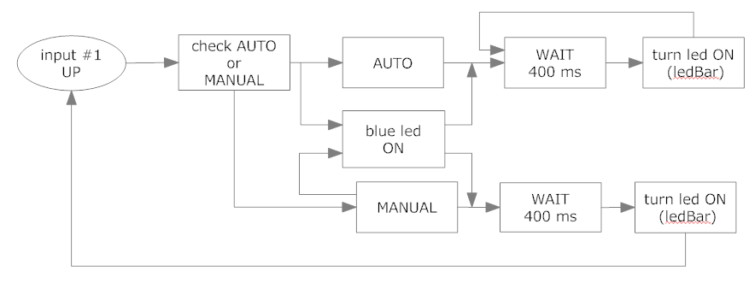

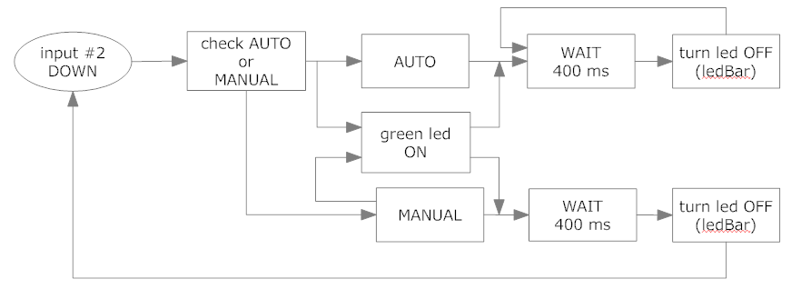

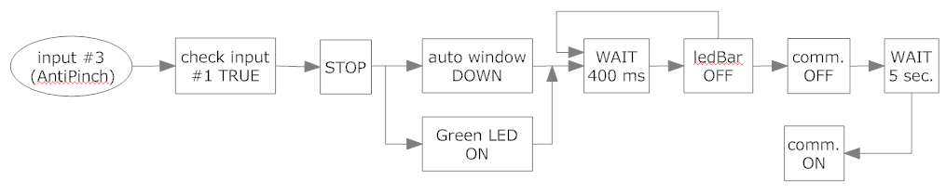

Uses Case Diagram for requirements analysis

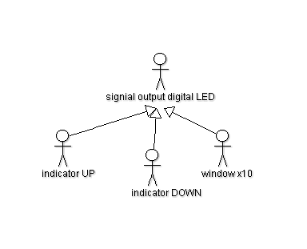
RF01, RF06

All indicator are LEDS
All indicators can have two states (High, Low)

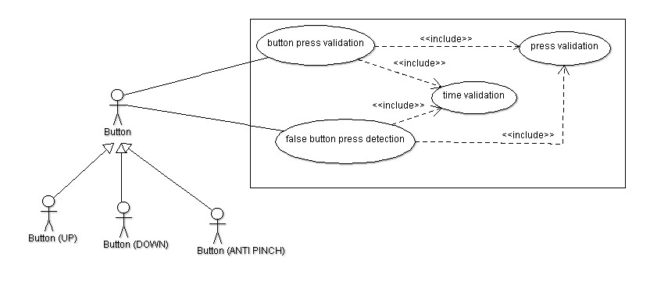
RF02, RF03, RF04, RF05

All pressed buttons have to be validated
All buttons have to be pressed at least 10 msec

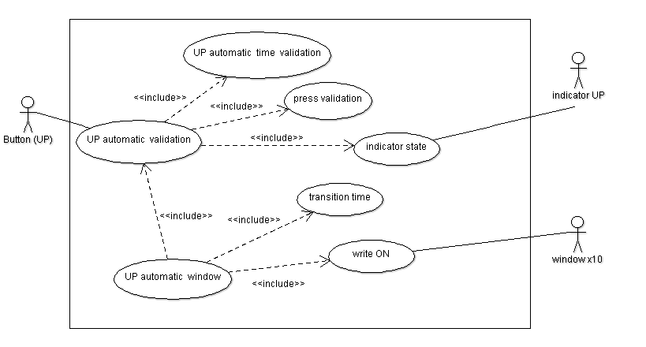
RF05, RF07

UP automatic have to be validated
Window closes automatically
The time between each transition time shall be 400 msc

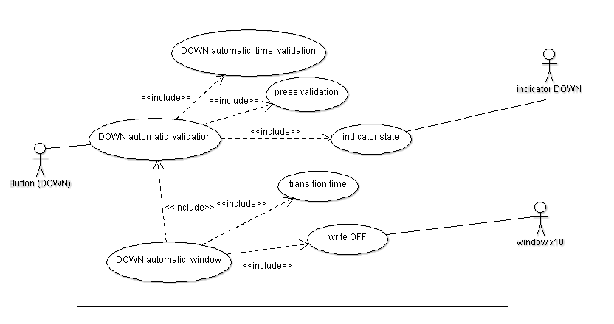
RF05, RF08

DOWN automatic have to be validated
Window opens automatically
The time between each transition time shall be 400 msc

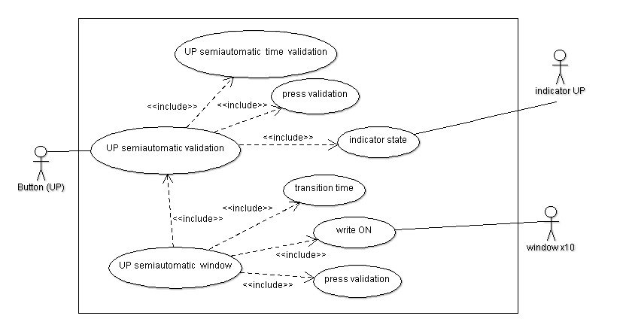
RF05, RF09

UP semiautomatic have to be validated
Window closes semiautomatically
The time between each transition time shall be 400 msc

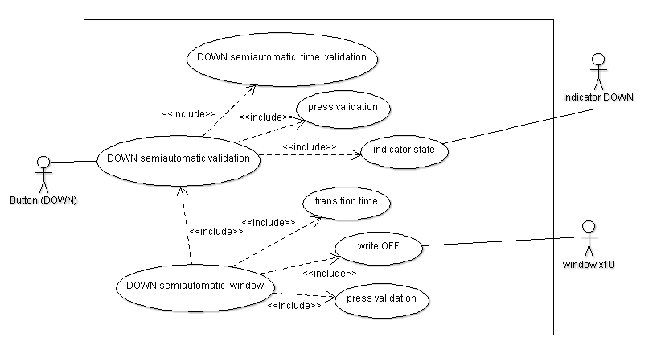
RF05, RF10

DOWN semiautomatic have to be validated
Window opens semiautomatically
The time between each transition time shall be 400 msc

SW Component internal breakdown

Activity diagrams to identify software components

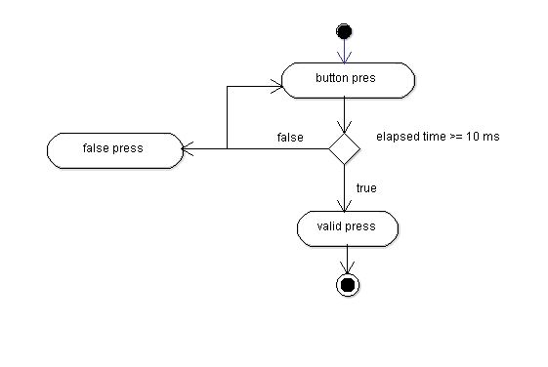
VALIDATE BUTTON PRESS

Function to get the status of a button (pressed/not pressed)
Function to start counting every 1 millisecond
Function to stop the counting
Interrupt Function of a timer
Variable to store the elapsed time
UP AUTOMATIC

Function to get the status of a button (pressed/not pressed)
Function to start counting every 1 millisecond
Function to stop the counting
Interrupt Function of a timer
Variable to store the elapsed time
Function to turn on the up indicator
Function to turn off the up indicator
Function to turn on the window´s leds sequentially (up control)
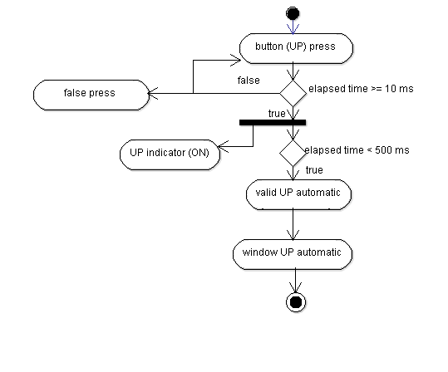
DOWN AUTOMATIC

Function to get the status of a button (pressed/not pressed)
Function to start counting every 1 millisecond
Function to stop the counting
Interrupt Function of a timer
Variable to store the elapsed time
Function to turn on the down indicator
Function to turn off the down indicator
Function to turn off the window´s leds sequentially (down control)
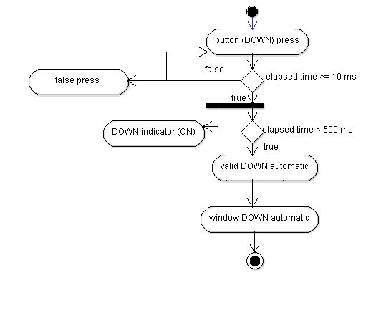

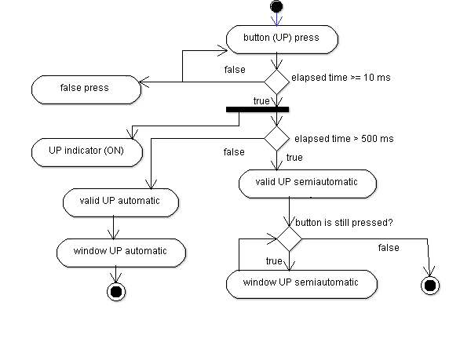
UP SEMIAUTOMATIC

Function to get the status of a button (pressed/not pressed)
Function to start counting every 1 millisecond
Function to stop the counting
Interrupt Function of a timer
Variable to store the elapsed time
Function to turn on the up indicator
Function to turn off the up indicator
Function to turn on the window´s leds sequentially (up control)

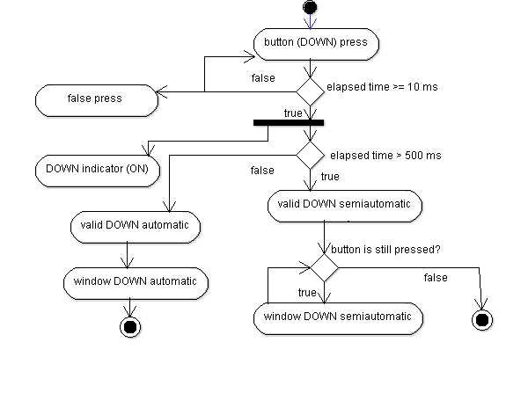
DOWN SEMIAUTOMATIC

Function to get the status of a button (pressed/not pressed)
Function to start counting every 1 millisecond
Function to stop the counting
Interrupt Function of a timer
Variable to store the elapsed time
Function to turn on the down indicator
Function to turn off the down indicator
Function to turn off the window´s leds sequentially (down control)

Antipinch
Interruption

Physical Block Diagram for Design Description

Microcontroller Abstracción Layer

Hardware Abstracción Layer

Services System Layer

Application Layer

main

app_buttonscontrol

app_indicatorscontrol

app_windowcontrol

app_timer1ms

app_initproyect
hal_buttons

hal_indicators
hal_windowleds

services_enableclc

services_enablenvic

services_enableports

services_initwd

services_timer

mal_S32K144
mal_namingconventions
mal_clocks

mal_interrup

mal_nvicinit

mal_pccports

mal_watchdog
mal_gpio

Function name | Files .c
void main(void)  void LPIT0_Ch0_IRQHandler(void)  void PORTE_IRQHandler(void) | main

Function name | Files .h/.c | Dependency
void ip_void_LPIT0Timer_init (void)  void ip_void_WindowInit (void)  void ip_void_IndicatorsInit (void)  void ip_void_EnablePCC (void)  void ip_void_ButtonsInit (void)  void ip_void_EnableClocksandModes (void)  void ip_void_EnableNVIC(void)  void ip_void_DisableWatchdog(void) | initproyect | Enableclc  Initwd  enableports  enablenvic  timer  buttons  indicators  windowleds
void tmr1ms_void_initTimer1ms()  void tmr1ms_void_EnableTimer1ms ()  void tmr1ms_void_DisableTimer1ms () | timer1ms | timer
T_UBYTE bc_T_UBYTE_statusButt_Up()  T_UBYTE bc_T_UBYTE_statusButt_Down() | buttonscontrol | buttons
void ic_void_onIndicator_Up()  void ic_void_offIndicator_Up()  void ic_void_onIndicator_Down()  void ic_void_offIndicator_Down() | indicatorscontrol | indicators
void wc_void_ControlWindowUp (T_UBYTE * porcent)  void wc_void_ControlWindowDown (T_UBYTE * porcent) | windowcontrol | windowleds

Function name | Files .h/.c | Dependency
void enableclc_vod_init_ClocksandModes(void) | enableclc | clocks
void initwd_void_initWatchdog(S_WDOG_Type * pWD, T_UWORD CNT, T_UWORD TOVAL, T_UWORD CS) | initwd | watchdog
void enableports_void_enable_PCC_Port(T_UWORD configPCC) | enableports | pccport
void enablenvic_void_NVIC_init_IRQs(void) | enablenvic | nvicinit
void timer_void_initLPIT0_Timer(S_PCC_Type *pPCC, S_LPIT_Type *pLPIT,T_UWORD clocksrc, T_UWORD enablelpit0, T_UWORD chanel)  void timer_void_configTime(S_LPIT_Type *pLPIT, T_UWORD period)  void timer_void_enable_Timer(S_LPIT_Type *pLPIT, T_UWORD period)  void timer_void_disable_Timer(S_LPIT_Type *pLPIT) | timer | interrup

Function name | Files .h/.c | Dependency
void buttons_void_config_Buttons_Port(S_GPIO_Type* PT, S_PORT_Type * PORT, T_UWORD numbit, T_UWORD mux)  T_UBYTE buttons_T_UBYTE_get_Button_Value(S_GPIO_Type* PT,T_UWORD numbit) | buttons | gpio
void indicator_void_config_indicator(S_GPIO_Type* PT, S_PORT_Type * PORT, T_UWORD numbit, T_UWORD mux)  void indicator_void_set_indicator(S_GPIO_Type* PT, T_UWORD numbit)  void indicator_void_clear_indicator(S_GPIO_Type* PT, T_UWORD numbit) | indicators | gpio
void windowleds_void_config_Led_Port(S_GPIO_Type *PT, S_PORT_Type * PORT, T_UWORD numbit, T_UWORD mux)  void windowleds_void_openBit_Window(S_GPIO_Type *PT, T_UWORD numbit)  void windowleds_void_closeBit_Window(S_GPIO_Type *PT, T_UWORD numbit) | windowleds | gpio

Function name | Files .h/.c | Dependency
void clocks_void_SOSC_init_8MHz(void)  void clocks_void_SPLL_init_160MHz(void)  void clocks_void_NormalRUNmode_80MHz (void) | clocks | namingconvention  S32K144
void watchdog_void_config_watchdog(S_WDOG_Type * pWD, int CNT, int TOVAL, int CS ) | watchdog | namingconvention  S32K144
void pccports_void_config_PCC_PORT(T_UWORD configPCC) | pccport | namingconvention  S32K144
void nvicinit_void_NVIC_init_IRQs (void) | nvicinit | namingconvention  S32K144
void interrup_void_enableClocks(S_PCC_Type *pPCC, T_UWORD clocksrc, T_UWORD enablelpit0)  void interrup_void_configureTimerChanel(S_LPIT_Type *pLPIT, T_UWORD chanel)  void interrup_void_ch0TimeoutPeriodClocks(S_LPIT_Type *pLPIT, T_UWORD period)  void interrup_void_enableTimer(S_LPIT_Type *pLPIT, T_UWORD period)  void interrup_void_disableTimer(S_LPIT_Type *pLPIT) | interrup | namingconvention  S32K144
void gpio_void_config_Pin_Out(S_GPIO_Type* PT, T_UWORD numbit)  void gpio_void_config_Pin_Mux(S_PORT_Type * PORT, T_UWORD numbit, T_UWORD mux)  void gpio_void_config_Pin_Int(S_GPIO_Type* PT, T_UWORD numbit)  void gpio_void_io_Set_Pin(S_GPIO_Type* PT,T_UWORD numbit)  void gpio_void_io_Clear_Pin(S_GPIO_Type* PT,T_UWORD numbit)  T_UBYTE gpio_T_UBYTE_io_GetValue_Pin(S_GPIO_Type* PT,T_UWORD numbit) | gpio | namingconvention  S32K144

Functional Decomposition
bc_T_UBYTE_statusButt_Up()
_______________________________________________________
* Returns the state of the pin wich is connected to a button (Up)
* Returns 1 if the state is high (+-5v)
* Returns 0 if the state is low (+-0v)
tmr1ms_void_EnableTimer1ms ()
_______________________________________________________
* Enables the timer to generate an interrupt every 1 millisecond

ic_void_onIndicator_Up()
_______________________________________________________
* Turns on the indicator LED (Up)
void LPIT0_Ch0_IRQHandler ()
_______________________________________________________
* Every 1 millisecond updates the value of a counter

ic_void_offIndicator_Down()
_______________________________________________________
* Turns off the indicator LED (Down)

tmr1ms_void_DisableTimer1ms ()
_______________________________________________________
* Disables the timer

bc_T_UBYTE_statusButt_Down()
_______________________________________________________
* Returns the state of the pin wich is connected to a button (Down)
* Returns 1 if the state is high (+-5v)
* Returns 0 if the state is low (+-0v)

ic_void_onIndicator_Down()
_______________________________________________________
* Turns on the indicator LED (Down)
ic_void_offIndicator_Up()
_______________________________________________________
* Turns off the indicator LED (Up)

wc_void_ControlWindowUp (T_UBYTE * porcent)
_______________________________________________________
* Turns on the window´s leds sequentially
* The time between each transition is 400 milliseconds
* Modifies the value of a variable (pointer)

bc_T_UBYTE_statusButt_Up()

wc_void_ControlWindowDown (T_UBYTE * porcent)
_______________________________________________________
* Turns off the window´s leds sequentially
* The time between each transition is 400 milliseconds
* Modifies the value of a variable (pointer)

bc_T_UBYTE_statusButt_Down()

void LPIT0_Ch0_IRQHandler (void)

void PORTE_IRQHandler (void)

Function Description and Dynamic Behavior

void wc_void_ControlWindowUp (T_UBYTE * porcent)
Description | This function controls the up movement, modifies the value of a pointer wich represents the position of the window
Parameter 1 | Receives a pointer to integer to increment its value.
Return Value | void
Precondition | the window´s leds off, executed inside main
Post condition | the window´s leds on

Dynamic Behavior
start

* porcent

* porcent

default
Turn on bit 10 window
case 10

>10

case 1
Turn on bit 1 window
Turn on bit 2 window
Turn on bit 3 window
Turn on bit 4 window
Turn on bit 5 window
Turn on bit 6 window
Turn on bit 7 window
Turn on bit 8 window
Turn on bit 9 window
case 2
case 3
case 4
case 5
case 6
case 7
case 8
case 9
* porcent = 10

Turn on bit n window
windowleds_void_openBit_Window(S_GPIO_Type *PT, T_UWORD numbit)

gpio_void_io_Set_Pin(S_GPIO_Type* PT,T_UWORD numbit)

void wc_void_ControlWindowDown (T_UBYTE * porcent)
Description | This function controls the down movement, modifies the value of a pointer wich represents the position of the window
Parameter 1 | Receives a pointer to integer to decrement its value.
Return Value | void
Precondition | the window´s leds on, executed inside main
Post condition | the window´s leds off

Dynamic Behavior
start

* porcent

* porcent

default
Turn off bit 10 window
case 10

<1

case 1
Turn off bit 1 window
Turn off bit 2 window
Turn off bit 3 window
Turn off bit 4 window
Turn off bit 5 window
Turn off bit 6 window
Turn off bit 7 window
Turn off bit 8 window
Turn off bit 9 window
case 2
case 3
case 4
case 5
case 6
case 7
case 8
case 9
* porcent = 1

Turn off bit n window
windowleds_void_closeBit_Window(S_GPIO_Type *PT, T_UWORD numbit)

gpio_void_io_Clear_Pin(S_GPIO_Type* PT,T_UWORD numbit)

T_UBYTE bc_ T_UBYTE _statusButt_Up ()
Description | This function returns the value 1 (Byte) if the pin receives a high voltage signial
Parameter 1 | void
Return Value | T_UBYTE
Precondition | Low voltage singial, executed inside main, called function, connected pin to Up button
Post condition | Value 1(Byte) if the signial is high or value 0 (Byte) if the signial is Low

Dynamic Behavior

start
Button pin == TRUE

Return a Byte value

Return a Byte value

T_UBYTE buttons_T_UBYTE_get_Button_Value(S_GPIO_Type* PT,T_UWORD numbit)
gpio_T_UBYTE_io_GetValue_Pin(PT,numbit)numbit)
True
False
Return
0xb00000001

Return
0xb00000000

T_UBYTE bc_ T_UBYTE _statusButt_Down ()
Description | This function returns the value 1 (Byte) if the pin receives a high voltage signial
Parameter 1 | void
Return Value | T_UBYTE
Precondition | Low voltage singial, executed inside main, called function, connected pin to Down button
Post condition | Value 1(Byte) if the signial is high or value 0 (Byte) if the signial is Low

Dynamic Behavior

start
Button pin == TRUE

Return a Byte value

Return a Byte value

T_UBYTE buttons_T_UBYTE_get_Button_Value(S_GPIO_Type* PT,T_UWORD numbit)
gpio_T_UBYTE_io_GetValue_Pin(PT,numbit)numbit)
True
False
Return
0xb00000001

Return
0xb00000000

void ic_void_onIndicator_Up ()
Description | This function turns on the Up indicator
Parameter 1 | void
Return Value | void
Precondition | turned off up indicator,executed inside main
Post condition | turned on up indicator

Dynamic Behavior

start
Set a pin (indicator Up)

Set a pin (indicator Up)

indicator_void_set_indicator(S_GPIO_Type* PT, T_UWORD numbit)
gpio_void_io_Set_Pin(S_GPIO_Type* PT,T_UWORD numbit)
v

void ic_void_offIndicator_Up ()
Description | This function turns off the Up indicator
Parameter 1 | void
Return Value | void
Precondition | turned on up indicator, executed inside main
Post condition | turned off up indicator

Dynamic Behavior

start
Clear a pin (indicator Up)

indicator_void_clear_indicator(S_GPIO_Type* PT, T_UWORD numbit)
gpio_void_io_Clear_Pin(S_GPIO_Type* PT,T_UWORD numbit)
v
Clear a pin (indicator Up)

void ic_void_onIndicator_Down ()
Description | This function turns on the Down indicator
Parameter 1 | void
Return Value | void
Precondition | turned off Down indicator, executed inside main
Post condition | turned on Down indicator

Dynamic Behavior

start
Set a pin (indicator Down)

indicator_void_set_indicator(S_GPIO_Type* PT, T_UWORD numbit)
gpio_void_io_Set_Pin(S_GPIO_Type* PT,T_UWORD numbit)
v

Set a pin (indicator Down)

void ic_void_offIndicator_Down ()
Description | This function turns off the Down indicator
Parameter 1 | void
Return Value | void
Precondition | turned on Down indicator, executed inside main
Post condition | turned off Down indicator

Dynamic Behavior

start
Clear a pin (indicator Down)

indicator_void_clear_indicator(S_GPIO_Type* PT, T_UWORD numbit)
gpio_void_io_Clear_Pin(S_GPIO_Type* PT,T_UWORD numbit)
v

Clear a pin (indicator Down)

void tmr1ms_void_EnableTimer1ms ()
Description | This function enables the timer´s interrup and assigns a value to the timer´s counter
Parameter 1 | void
Return Value | void
Precondition | Disabled interrup, executed inside main
Post condition | Enabled interrup, counter decrements its value

Dynamic Behavior

Enabled timer´s interrup
Value of timer´s´counter

start
timer_void_enable_Timer(S_LPIT_Type *pLPIT, T_UWORD period)
interrup_void_enableTimer(S_LPIT_Type *pLPIT, T_UWORD period)v

Enabled timer´s interrup
Value of timer´s´counter

void tmr1ms_void_DisableTimer1ms ()
Description | This function disables the timer´s interrup
Parameter 1 | void
Return Value | void
Precondition | Enabled interrup, executed inside main
Post condition | Disabled interrup

Dynamic Behavior

start
timer_void_disable_Timer(S_LPIT_Type *pLPIT, T_UWORD period)
interrup_void_disableTimer(S_LPIT_Type *pLPIT, T_UWORD period)v
Disabled timer´s interrup

Disabled timer´s interrup

